CHAPTER 14
Breathing and Exchange of Gases

14.0 | Why We Breathe

Oxygen (O₂) is utilised by organisms to indirectly break down simple molecules like glucose, amino acids and fatty acids to derive energy for various activities. Carbon dioxide (CO₂), which is harmful, is released during these catabolic reactions. It therefore becomes essential that O₂ is continuously provided to the cells and the CO₂ produced by the cells is released out.
• Breathing: the process of exchange of O₂ from the atmosphere with CO₂ produced by the cells. It is commonly known as respiration.
14.1 | Respiratory Organs

Mechanisms of breathing vary among different groups of animals depending mainly on their habitats and levels of organisation.
Animal group | Respiratory structure / mechanism | Named term
Lower invertebrates - sponges, coelenterates, flatworms | Exchange O₂ with CO₂ by simple diffusion over their entire body surface | Diffusion
Earthworms | Use their moist cuticle to exchange gases | Cutaneous
Insects | A network of tubes (tracheal tubes) transports atmospheric air within the body | Tracheal
Most aquatic arthropods and molluscs | Special vascularised structures called gills | Branchial respiration
Terrestrial forms | Vascularised bags called lungs | Pulmonary respiration

Among vertebrates, fishes use gills whereas amphibians, reptiles, birds and mammals respire through lungs. Amphibians like frogs can also respire through their moist skin (cutaneous respiration).
14.1.1 | Human Respiratory System

We have a pair of external nostrils opening out above the upper lips. These lead to a nasal chamber through the nasal passage. The nasal chamber opens into the pharynx, a portion of which is the common passage for food and air. The pharynx opens through the larynx region into the trachea.
• Larynx: a cartilaginous box which helps in sound production and hence is called the sound box.
During swallowing, the glottis can be covered by a thin elastic cartilaginous flap called epiglottis to prevent the entry of food into the larynx.
14.1.1a | The Airway, Branch by Branch

1 | Trachea - a straight tube extending up to the mid-thoracic cavity.
2 | The trachea divides at the level of the 5th thoracic vertebra into a right and left primary bronchi. (Each such division gives a Bronchus.)
3 | Each bronchus undergoes repeated divisions to form the secondary and tertiary bronchi and bronchioles, ending up in very thin terminal bronchioles. (A single such branch is a Bronchiole.)
4 | Each terminal bronchiole gives rise to a number of very thin, irregular-walled and vascularised bag-like structures called alveoli.

The trachea, primary, secondary and tertiary bronchi, and initial bronchioles are supported by incomplete cartilaginous rings. The branching network of bronchi, bronchioles and alveoli comprises the lungs - we have two lungs. Each Lung is covered by a double-layered pleura, with pleural fluid between its two layers, and this pleural fluid reduces friction on the lung-surface. Of the two pleural membranes, the outer one is in close contact with the thoracic lining whereas the inner one is in contact with the lung surface.
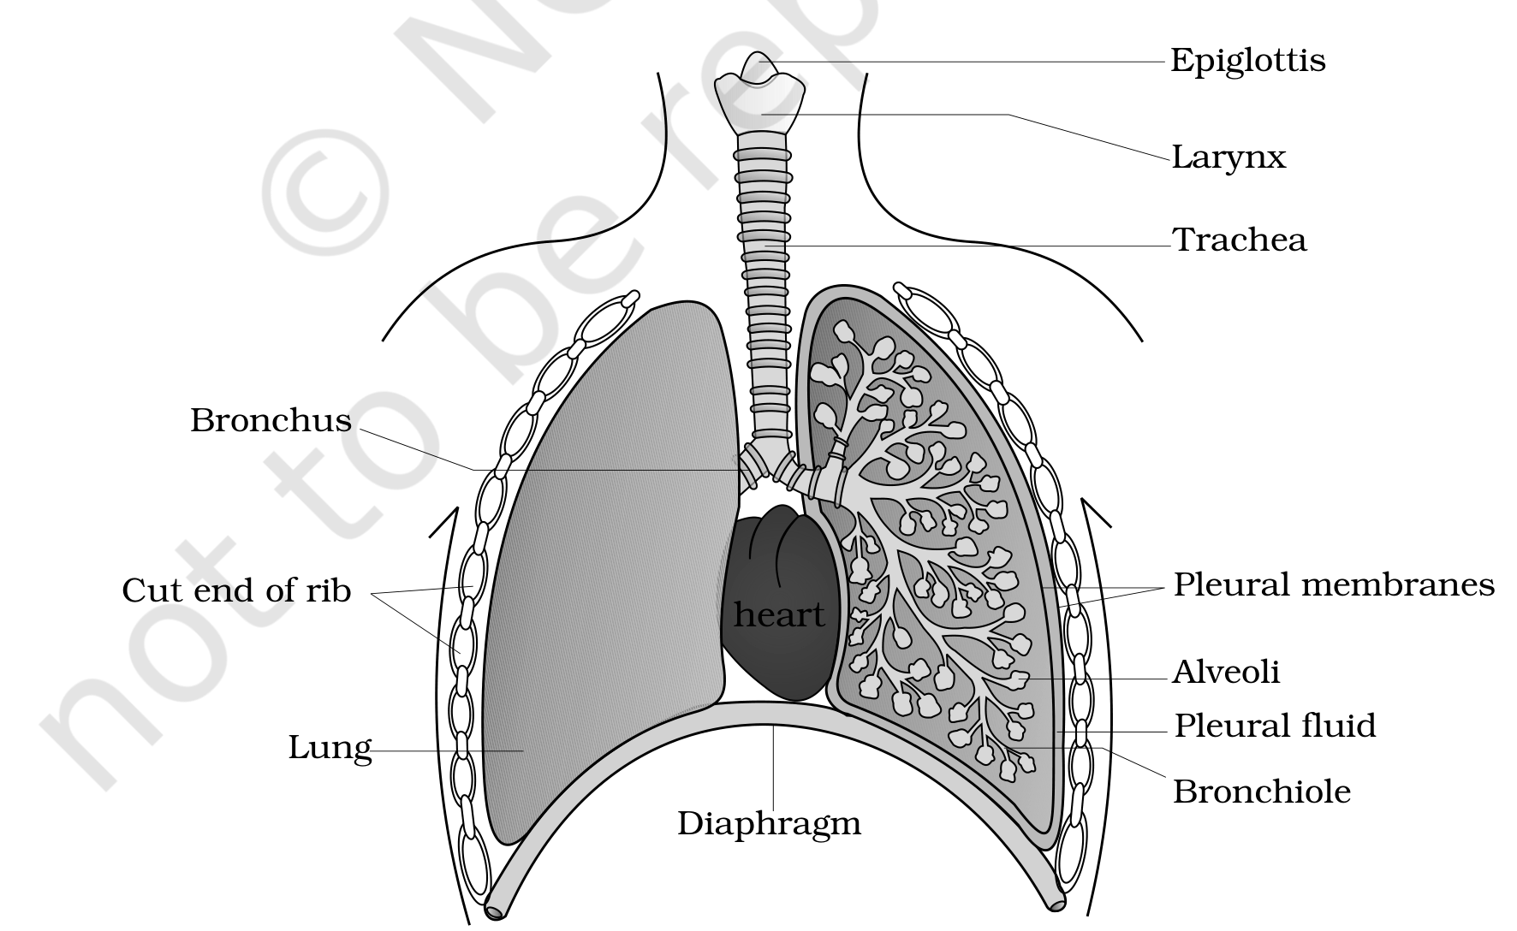
Fig. 14.1 - Diagrammatic view of the human respiratory system (a sectional view of the left lung is also shown). Labelled from top down: Epiglottis, Larynx, Trachea, and the Bronchus entering each lung, dividing into a Bronchiole that ends in Alveoli; the Cut end of rib and the two Pleural membranes with Pleural fluid between them enclose the Lung, with the heart lying between the lungs and the dome-shaped Diaphragm below.
14.1.1b | Conducting Part vs Exchange Part

Part | Extent | Function
Conducting part | From the external nostrils up to the terminal bronchioles | Transports the atmospheric air to the alveoli, clears it from foreign particles, humidifies it and brings the air to body temperature
Respiratory or exchange part | The alveoli and their ducts | The site of actual diffusion of O₂ and CO₂ between blood and atmospheric air

14.1.1c | The Thoracic Chamber

The lungs are situated in the thoracic chamber, which is anatomically an air-tight chamber. It is formed dorsally by the vertebral column, ventrally by the sternum, laterally by the ribs and on the lower side by the dome-shaped diaphragm. The anatomical setup is such that any change in the volume of the thoracic cavity is reflected in the pulmonary (lung) cavity. Such an arrangement is essential for breathing, as we cannot directly alter the pulmonary volume.
[NOTE] Respiration in humans involves the following five steps, in this order: (i) Breathing or pulmonary ventilation, by which atmospheric air is drawn in and CO₂-rich alveolar air is released out; (ii) diffusion of gases (O₂ and CO₂) across the alveolar membrane; (iii) transport of gases by the blood; (iv) diffusion of O₂ and CO₂ between blood and tissues; and (v) utilisation of O₂ by the cells for catabolic reactions and resultant release of CO₂ (cellular respiration).

14.2 | Mechanism of Breathing

Breathing involves two stages: inspiration, during which atmospheric air is drawn in, and expiration, by which the alveolar air is released out. The movement of air into and out of the lungs is carried out by creating a pressure gradient between the lungs and the atmosphere.
• Inspiration can occur if the pressure within the lungs (intra-pulmonary pressure) is less than the atmospheric pressure, i.e. there is a negative pressure in the lungs with respect to atmospheric pressure.
• Expiration takes place when the intra-pulmonary pressure is higher than the atmospheric pressure.
The diaphragm and a specialised set of muscles - external and internal intercostals between the ribs - help in the generation of such pressure gradients.
14.2a | Inspiration, Step by Step

1 | Inspiration is initiated by the contraction of the diaphragm, which increases the volume of the thoracic chamber in the antero-posterior axis. In the figure this is the Diaphragm contracted state.
2 | Contraction of the external inter-costal muscles lifts up the ribs and the sternum - Ribs and sternum raised - causing an increase in the volume of the thoracic chamber in the dorso-ventral axis, expanding the Rib cage.
3 | The overall increase in thoracic volume causes a similar increase in pulmonary volume, so the Volume of thorax increased.
4 | An increase in pulmonary volume decreases the intra-pulmonary pressure to less than the atmospheric pressure, which forces air from outside to move into the lungs - Air entering lungs. This is inspiration.

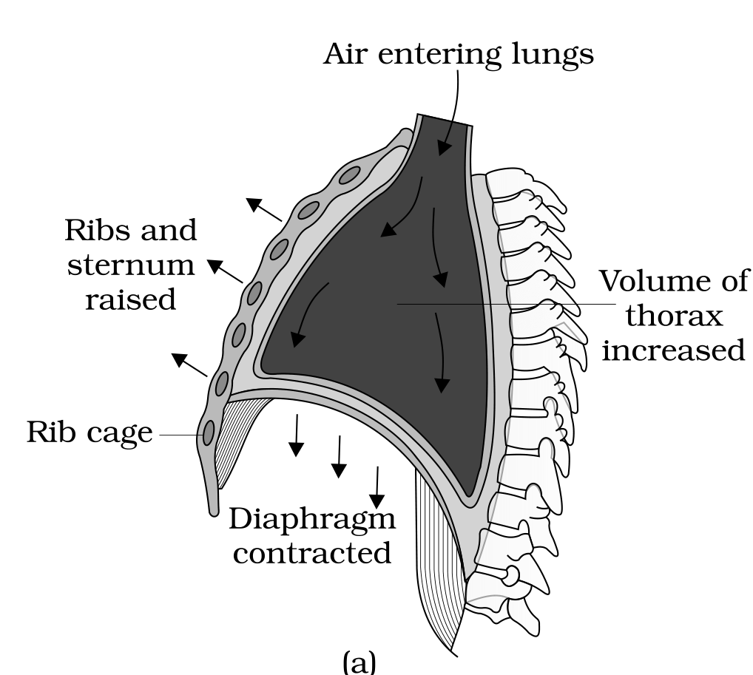
Fig. 14.2 (a) - Mechanism of breathing showing inspiration: the Rib cage with Ribs and sternum raised, the Diaphragm contracted and flattened, the Volume of thorax increased, and Air entering lungs.
14.2b | Expiration, Step by Step

1 | Relaxation of the diaphragm and the inter-costal muscles returns the diaphragm and sternum to their normal positions - the Diaphragm relaxed and arched upwards, and the Ribs and sternum returned to original position - reducing the thoracic volume and thereby the pulmonary volume, so the Volume of thorax decreased.
2 | This reduction leads to an increase in intra-pulmonary pressure to slightly above the atmospheric pressure, causing the expulsion of air from the lungs - Air expelled from lungs. This is expiration.

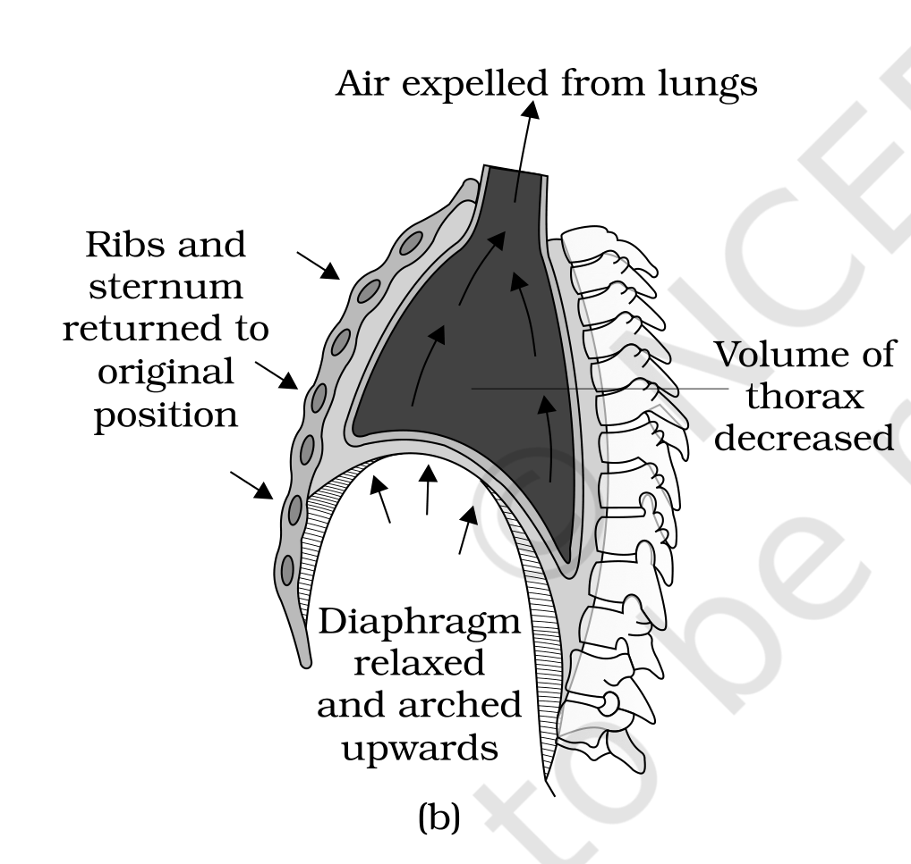
Fig. 14.2 (b) - Mechanism of breathing showing expiration: the Ribs and sternum returned to original position, the Diaphragm relaxed and arched upwards, the Volume of thorax decreased, and Air expelled from lungs.
We can increase the strength of inspiration and expiration with the help of additional muscles in the abdomen. On an average, a healthy human breathes 12-16 times per minute.
• Spirometer: the instrument with which the volume of air involved in breathing movements can be estimated. It helps in the clinical assessment of pulmonary functions.
14.2.1 | Respiratory Volumes and Capacities

A healthy man can inspire or expire approximately 6000 to 8000 mL of air per minute. The individual volumes below are what a spirometer measures.
Volume | Definition | Average value
Tidal Volume (TV) | Volume of air inspired or expired during a normal respiration | Approx. 500 mL
Inspiratory Reserve Volume (IRV) | Additional volume of air a person can inspire by a forcible inspiration | 2500 mL to 3000 mL
Expiratory Reserve Volume (ERV) | Additional volume of air a person can expire by a forcible expiration | 1000 mL to 1100 mL
Residual Volume (RV) | Volume of air remaining in the lungs even after a forcible expiration | 1100 mL to 1200 mL

By adding up a few respiratory volumes, one can derive various pulmonary capacities, which can be used in clinical diagnosis.
Capacity | Definition | Formula
Inspiratory Capacity (IC) | Total volume of air a person can inspire after a normal expiration | TV + IRV
Expiratory Capacity (EC) | Total volume of air a person can expire after a normal inspiration | TV + ERV
Functional Residual Capacity (FRC) | Volume of air that will remain in the lungs after a normal expiration | ERV + RV
Vital Capacity (VC) | The maximum volume of air a person can breathe in after a forced expiration, or breathe out after a forced inspiration | ERV + TV + IRV
Total Lung Capacity (TLC) | Total volume of air accommodated in the lungs at the end of a forced inspiration | RV + ERV + TV + IRV, i.e. vital capacity + residual volume

[MEMORY AID - not in NCERT] The four capacities built by addition all start from a volume you already know: Inspiratory Capacity adds the inspiratory pair (TV + IRV), Expiratory Capacity adds the expiratory pair (TV + ERV) - the letter before 'C' tells you which reserve joins the tidal volume. FRC is what is left behind (ERV + RV), and TLC is simply VC + RV.

14.3 | Exchange of Gases

Alveoli are the primary sites of exchange of gases. Exchange of gases also occurs between blood and tissues. O₂ and CO₂ are exchanged at these sites by simple diffusion, mainly based on pressure/concentration gradient. Solubility of the gases and the thickness of the membranes involved in diffusion are important factors that can affect the rate of diffusion.
• Partial pressure: the pressure contributed by an individual gas in a mixture of gases. It is represented as pO₂ for oxygen and pCO₂ for carbon dioxide.
Table 14.1 - Partial pressures (in mm Hg) of oxygen and carbon dioxide at different parts involved in diffusion
Respiratory gas | Atmospheric air | Alveoli | Blood (deoxygenated) | Blood (oxygenated) | Tissues
pO₂ | 159 | 104 | 40 | 95 | 40
pCO₂ | 0.3 | 40 | 45 | 40 | 45

The data in Table 14.1 indicate a concentration gradient for oxygen from alveoli to blood and from blood to tissues. Similarly, a gradient for CO₂ is present in the opposite direction, i.e. from tissues to blood and from blood to alveoli.
As the solubility of CO₂ is 20-25 times higher than that of O₂, the amount of CO₂ that can diffuse through the diffusion membrane per unit difference in partial pressure is much higher compared to that of O₂.
14.3a | The Diffusion Membrane

The diffusion membrane is made up of three major layers: the thin squamous epithelium of alveoli, the endothelium of alveolar capillaries and the basement substance in between them. The basement substance is composed of a thin basement membrane supporting the squamous epithelium and the basement membrane surrounding the single-layer endothelial cells of the capillaries. However, its total thickness is much less than a millimetre.
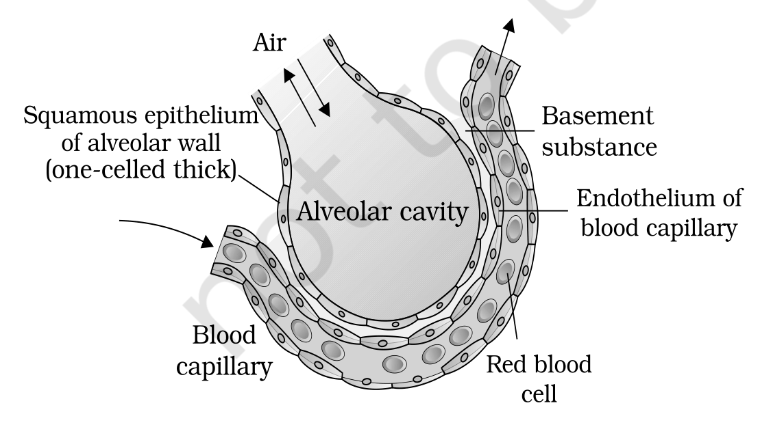
Fig. 14.4 - A diagram of a section of an alveolus with a pulmonary capillary. The Air in the Alveolar cavity is separated from the Blood capillary by the three layers of the diffusion membrane: the Squamous epithelium of alveolar wall, the Basement substance and the Endothelium of blood capillary; a Red blood cell is shown inside the capillary.
[NOTE] All the factors in our body are favourable for diffusion of O₂ from alveoli to tissues and of CO₂ from tissues to alveoli. This is why diffusion of gases occurs in the alveolar region only and not in the other parts of the respiratory system: only there does a vascularised, thin, three-layered diffusion membrane lie between air and blood, while the rest of the tract - the conducting part - has thick, cartilage-supported walls and merely carries, cleans, humidifies and warms the air.

14.4 | Transport of Gases

Blood is the medium of transport for O₂ and CO₂.
Gas | Carried by | Share
O₂ | RBCs in the blood | About 97 per cent
O₂ | Dissolved state through the plasma | Remaining 3 per cent
CO₂ | RBCs | Nearly 20-25 per cent
CO₂ | As bicarbonate | About 70 per cent
CO₂ | Dissolved state through plasma | About 7 per cent

14.4.1 | Transport of Oxygen

• Haemoglobin: a red-coloured, iron-containing pigment present in the RBCs.
O₂ can bind with haemoglobin in a reversible manner to form oxyhaemoglobin. Each haemoglobin molecule can carry a maximum of four molecules of O₂. Binding of oxygen with haemoglobin is primarily related to the partial pressure of O₂. Partial pressure of CO₂, hydrogen ion concentration and temperature are the other factors which can interfere with this binding.
• Oxygen dissociation curve: the sigmoid curve obtained when the percentage saturation of haemoglobin with O₂ is plotted against pO₂. It is highly useful in studying the effect of factors like pCO₂ and H⁺ concentration on the binding of O₂ with haemoglobin.
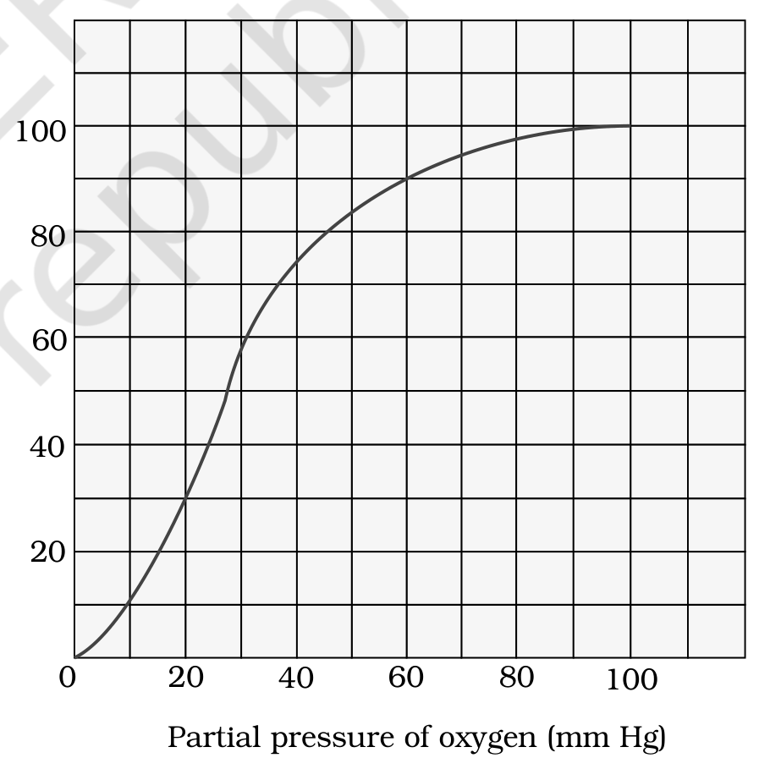
Fig. 14.5 - Oxygen dissociation curve. The vertical axis is the Percentage saturation of haemoglobin with oxygen and the horizontal axis is the Partial pressure of oxygen (mm Hg); the plotted sigmoid line is the Oxygen dissociation curve itself.
Site | Conditions | Result
In the alveoli | High pO₂, low pCO₂, lesser H⁺ concentration and lower temperature | The factors are all favourable for the formation of oxyhaemoglobin
In the tissues | Low pO₂, high pCO₂, high H⁺ concentration and higher temperature | Conditions are favourable for dissociation of oxygen from oxyhaemoglobin

This clearly indicates that O₂ gets bound to haemoglobin at the lung surface and gets dissociated at the tissues. Under normal physiological conditions, every 100 mL of oxygenated blood can deliver around 5 mL of O₂ to the tissues.
[NOTE] Effect of pCO₂ on oxygen transport (Exercise 8): a high pCO₂, which also raises the H⁺ concentration, is one of the tissue-side conditions that favours dissociation of O₂ from oxyhaemoglobin. A low pCO₂, as in the alveoli, favours formation of oxyhaemoglobin instead. So pCO₂ does not carry the oxygen, but it decides where the oxygen is released.

14.4.2 | Transport of Carbon dioxide

CO₂ is carried by haemoglobin as carbamino-haemoglobin (about 20-25 per cent). This binding is related to the partial pressure of CO₂. pO₂ is a major factor which could affect this binding.
• When pCO₂ is high and pO₂ is low, as in the tissues, more binding of carbon dioxide occurs.
• When pCO₂ is low and pO₂ is high, as in the alveoli, dissociation of CO₂ from carbamino-haemoglobin takes place - i.e. the CO₂ bound to haemoglobin from the tissues is delivered at the alveoli.
• Carbonic anhydrase: RBCs contain a very high concentration of this enzyme, and minute quantities of the same is present in the plasma too.
This enzyme facilitates the following reaction in both directions:
CO₂ + H₂O <--carbonic anhydrase--> H₂CO₃ <--carbonic anhydrase--> HCO₃⁻ + H⁺
1 | At the tissue site, where pCO₂ is high due to catabolism, CO₂ diffuses into blood (RBCs and plasma) and forms HCO₃⁻ and H⁺.
2 | At the alveolar site, where pCO₂ is low, the reaction proceeds in the opposite direction, leading to the formation of CO₂ and H₂O.
3 | Thus CO₂ trapped as bicarbonate at the tissue level and transported to the alveoli is released out as CO₂.

Every 100 mL of deoxygenated blood delivers approximately 4 mL of CO₂ to the alveoli.
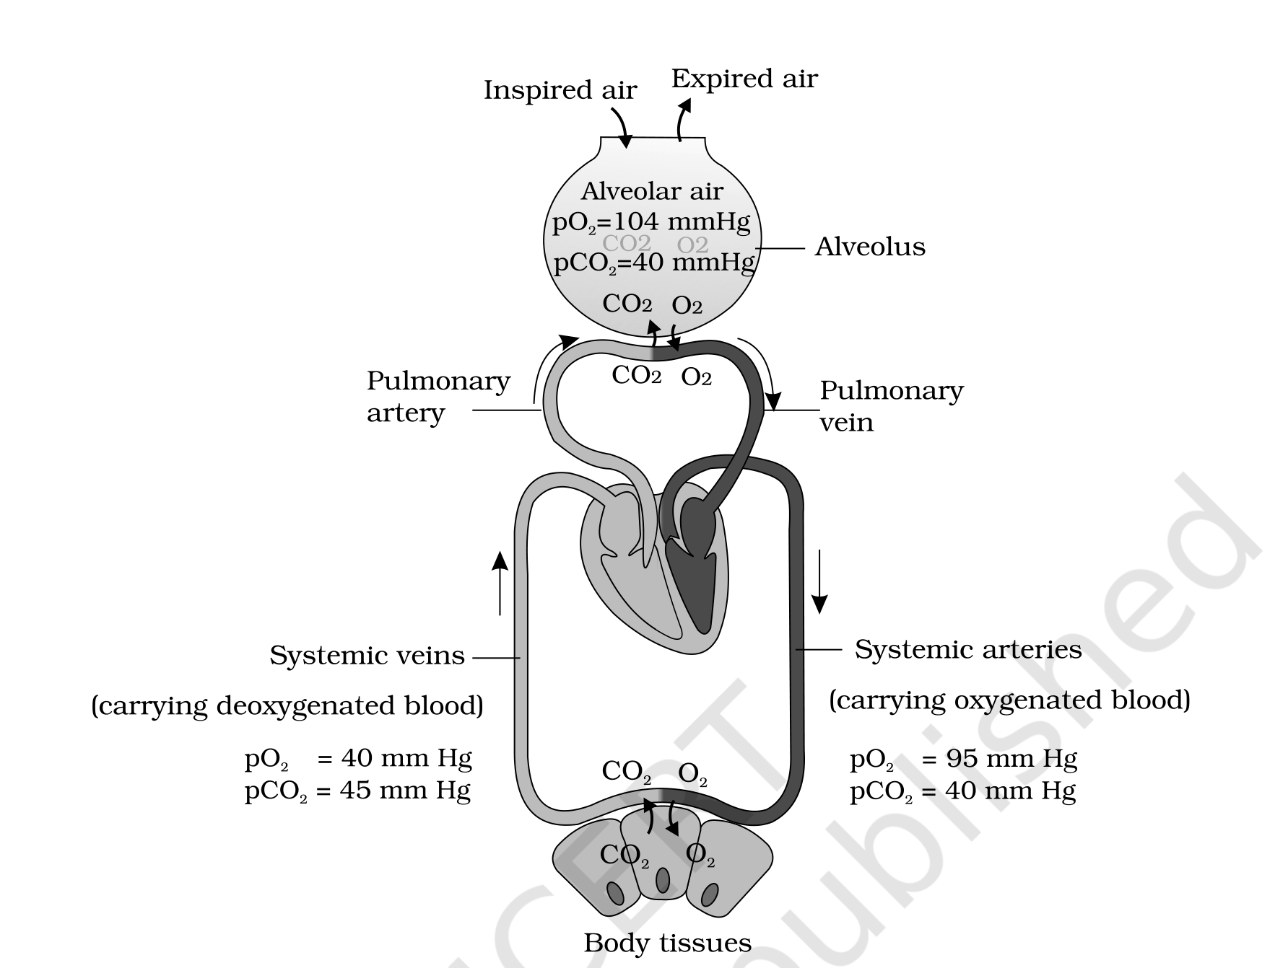
Fig. 14.3 - Diagrammatic representation of exchange of gases at the Alveolus and the Body tissues with blood, and transport of oxygen and carbon dioxide. Inspired air enters and Expired air leaves the alveolus, whose Alveolar air exchanges CO₂ and O₂ with the blood: the Pulmonary artery brings deoxygenated blood to the alveolus and the Pulmonary vein carries oxygenated blood away, while the Systemic arteries deliver it to the Body tissues and the Systemic veins return it. In the figure the two gases are marked CO2 and O2.
14.5 | Regulation of Respiration

Human beings have a significant ability to maintain and moderate the respiratory rhythm to suit the demands of the body tissues. This is done by the neural system.
• Respiratory rhythm centre: a specialised centre present in the medulla region of the brain, primarily responsible for this regulation.
• Pneumotaxic centre: another centre present in the pons region of the brain which can moderate the functions of the respiratory rhythm centre. Neural signal from this centre can reduce the duration of inspiration and thereby alter the respiratory rate.
• Chemosensitive area: situated adjacent to the rhythm centre, highly sensitive to CO₂ and hydrogen ions. Increase in these substances can activate this centre, which in turn can signal the rhythm centre to make necessary adjustments in the respiratory process by which these substances can be eliminated.
• Receptors associated with the aortic arch and carotid artery also can recognise changes in CO₂ and H⁺ concentration and send necessary signals to the rhythm centre for remedial actions.
[NOTE] The role of oxygen in the regulation of respiratory rhythm is quite insignificant. The regulation is driven by CO₂ and H⁺, not by O₂ - a favourite NEET assertion-reason trap.

14.6 | Disorders of Respiratory System

Disorder | What happens | Cause / note
Asthma | A difficulty in breathing causing wheezing | Due to inflammation of bronchi and bronchioles
Emphysema | A chronic disorder in which alveolar walls are damaged, due to which the respiratory surface is decreased | One of the major causes of this is cigarette smoking
Occupational Respiratory Disorders | In certain industries, especially those involving grinding or stone-breaking, so much dust is produced that the defence mechanism of the body cannot fully cope with the situation | Long exposure can give rise to inflammation leading to fibrosis (proliferation of fibrous tissues) and thus causing serious lung damage. Workers in such industries should wear protective masks.

Recap | Quick Recap

• Cells utilise oxygen for metabolism and produce energy along with substances like carbon dioxide which is harmful. Animals have evolved different mechanisms for the transport of oxygen to the cells and for the removal of carbon dioxide from there. We have a well developed respiratory system comprising two lungs and associated air passages.
• The first step in respiration is breathing, by which atmospheric air is taken in (inspiration) and the alveolar air is released out (expiration). Exchange of O₂ and CO₂ between deoxygenated blood and alveoli, transport of these gases throughout the body by blood, exchange of O₂ and CO₂ between the oxygenated blood and tissues and utilisation of O₂ by the cells (cellular respiration) are the other steps involved.
• Inspiration and expiration are carried out by creating pressure gradients between the atmosphere and the alveoli with the help of specialised muscles - intercostals and diaphragm. Volumes of air involved in these activities can be estimated with the help of a spirometer and are of clinical significance.
• Exchange of O₂ and CO₂ at the alveoli and tissues occurs by diffusion. The rate of diffusion is dependent on the partial pressure gradients of O₂ (pO₂) and CO₂ (pCO₂), their solubility as well as the thickness of the diffusion surface. These factors in our body facilitate diffusion of O₂ from the alveoli to the deoxygenated blood as well as from the oxygenated blood to the tissues, and are favourable for the diffusion of CO₂ in the opposite direction, i.e. from tissues to alveoli.
• Oxygen is transported mainly as oxyhaemoglobin. In the alveoli, where pO₂ is higher, O₂ gets bound to haemoglobin, which is easily dissociated at the tissues where pO₂ is low and pCO₂ and H⁺ concentration are high.
• Nearly 70 per cent of carbon dioxide is transported as bicarbonate (HCO₃⁻) with the help of the enzyme carbonic anhydrase. 20-25 per cent of carbon dioxide is carried by haemoglobin as carbamino-haemoglobin: in the tissues, where pCO₂ is high, it gets bound to blood, whereas in the alveoli, where pCO₂ is low and pO₂ is high, it gets removed from the blood.
• Respiratory rhythm is maintained by the respiratory centre in the medulla region of the brain. A pneumotaxic centre in the pons region of the brain and a chemosensitive area in the medulla can alter the respiratory mechanism.
Terms | Terms Used in the Exercises

Ex 9 | A man going up a hill (high altitude)

Going up a hill means climbing into thinner air, so the partial pressure of oxygen (pO₂) in the atmospheric air falls below its sea-level value of 159 mm Hg. Because binding of oxygen with haemoglobin is primarily related to the partial pressure of O₂, a lower atmospheric pO₂ means a lower alveolar pO₂, so less oxyhaemoglobin is formed and less O₂ is delivered per 100 mL of blood than the usual 5 mL. The body compensates through the very mechanism of SS14.5: the respiratory rhythm centre, prompted by the chemosensitive area and the receptors of the aortic arch and carotid artery, increases the rate and depth of breathing - the climber breathes faster and deeper than the normal 12-16 times per minute, using the additional muscles in the abdomen to strengthen inspiration and expiration.
Ex 11 | Why the oxygen dissociation curve is sigmoidal

Each haemoglobin molecule can carry a maximum of four molecules of O₂, and binding is reversible. The four binding events are not independent: the first O₂ molecule binds with difficulty, but once bound it makes the remaining sites bind more readily, and the last site fills only when pO₂ is high. So saturation rises slowly at low pO₂, steeply at intermediate pO₂, and flattens as the four sites fill up - which is exactly the S-shaped (sigmoid) curve of Fig. 14.5. The steep middle portion is the physiologically useful part: it is why a small fall in pO₂ at the tissues (40 mm Hg against the alveolar 104 mm Hg) unloads a large amount of O₂.
Ex 12 | Hypoxia

Hypoxia is a deficiency of oxygen reaching the body tissues - the tissues receive less O₂ than they need for the catabolic reactions that release energy. Reading it against this chapter, hypoxia is what results whenever any link in the five-step chain weakens: reduced ventilation (as in asthma, where inflammation of bronchi and bronchioles obstructs breathing), a reduced respiratory surface (as in emphysema, where alveolar walls are damaged, or in the fibrosis of occupational respiratory disorders), a fall in atmospheric pO₂ (high altitude), or too little haemoglobin to carry the 97 per cent of O₂ that travels in the RBCs.
Ex 14 | Tidal volume in an hour

Tidal Volume (TV) is the volume of air inspired or expired during a normal respiration, approximately 500 mL. A healthy human breathes 12-16 times per minute, i.e. 720 to 960 breaths per hour. Multiplying by the tidal volume gives about 360,000 to 480,000 mL per hour, i.e. roughly 360 to 480 litres of air per hour. (This agrees with the chapter's own figure that a healthy man can inspire or expire approximately 6000 to 8000 mL of air per minute.)
[MEMORY AID - not in NCERT] For the MCQ in Exercise 5, read Table 14.1 across one row at a time. Atmospheric air vs alveolar air: oxygen falls 159 to 104 (so atmospheric pO₂ is higher) while carbon dioxide rises 0.3 to 40 (so atmospheric pCO₂ is lesser). Air arriving from outside is oxygen-rich and carbon-dioxide-poor - which is the whole point of ventilating the alveoli.

